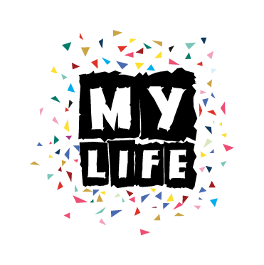

DELAWARE COUNTY
All Meetings are held at: The Unitarian Universalist Church of Delaware County
145 W. Rose Tree Rd. Media, PA 19063 the 1st Tuesday of each month from 5:30 to 7:30 pm. 1/15/19*; 2/5/19; 3/5/19; 4/2/19; 5/7/19; 6/4/19; 7/2/19; 8/6/19; 9/3/19; 10/1/19; & 11/5/19. December is TBD.
Contact Tammi Gabriel-Berrong for more information: (215) 504-3997 or Gabrielberrongt@MagellanHealth.com

Montgomery COUNTY
All Meetings are held at: Norristown Public Library 1001 Powell Street, Norristown, PA 19401 usually the 2nd Wednesday of each month from 5:00 to 7:00 pm. 1/9/19; 2/13/19; 3/13/19; 4/10/19; 5/8/19; 6/12/19; 7/10/19; 8/21/19*; 9/11/19; 10/9/19; & 11/13/19. December is TBD.
Contact Collette D’Angelo for more information: (610) 209-8590 or (610) 272-3042 ext. 318 or Colletted@centralbh.org.

Bucks COUNTY
All Meetings are held at: Christ’s Home Church 800 York Rd Warminster PA 18974 the 2nd Thursday of each month from 5:30 to 7:30 pm. 1/10/19; 2/14/19; 3/14/19; 4/11/19; 5/9/19; 6/13/19; 7/11/19; 8/8/19; 9/12/19; 10/10/19; 11/14/18; & 12/12/19.
Contact Marissa Gates for more information: (215) 504-3966 or MLGates@MagellanHealth.com

Lehigh Valley
All Meetings are held at: St. Paul’s United Church-Christ 340 E. Hamilton St. Allentown, PA 18109 usually the 2nd Friday of each month from 5:00 to 7:00 pm. 1/11/19; 2/8/19; 3/8/19; 4/12/19; 5/10/19; 6/14/19; 7/12/19; 8/9/19; 9/13/19; 10/11/19; 11/8/19; & 12/13/19
Contact Thalia Schmidt for more information: (610) 814-8055 or TESchmidt@MagellanHealth.com or Michele Davis: (610) 814-8006 or MLDavis@magellanhealth.com

CAMBRIA COUNTY
All Meetings are held at: Commerce Centre 1003 Broad Street, Johnstown, PA 15906 the 3rd Thursday of each month from 5:30 to 8:00 pm. 1/17/19; 2/21/19; 3/21/19; 4/18/19; 5/16/19; 6/20/19; 7/18/19; 8/15/19; 9/19/19; 10/17/19; 11/21/19; & 12/19/19
Contact Janna Burkett for more information: (814) 961-0687 or JBurkett@MagellanHealth.com
There is no cost for participation and dinner will be provided
Come be a part of MY LIFE!
An empowering leadership group for youth who have experience with mental health, substance abuse, foster care or juvenile justice issues; and who want to use their experience to help improve the systems that serve youth in Pennsylvania.
www.facebook.com/MYLIFEyouth
For more information on MY LIFE contact: Greg Dicharry at (602) 602-9135 or at GDdicharry@Magellanhealth.com

